Creating 4 VPC in different region

Created VPC in Frankfurt Region🡪VPC1

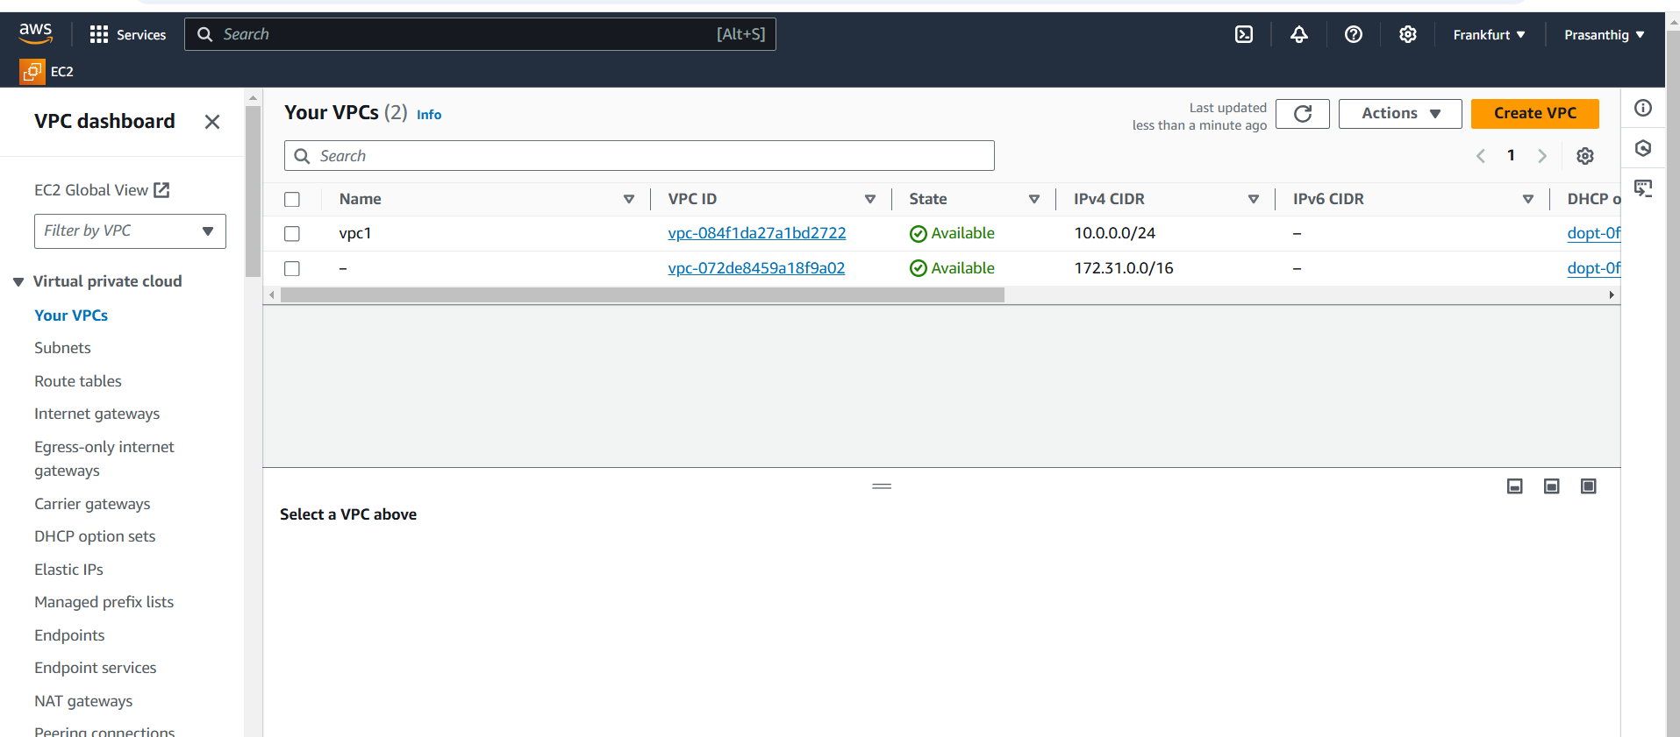

Created VPC in Ireland Region🡪VPC2

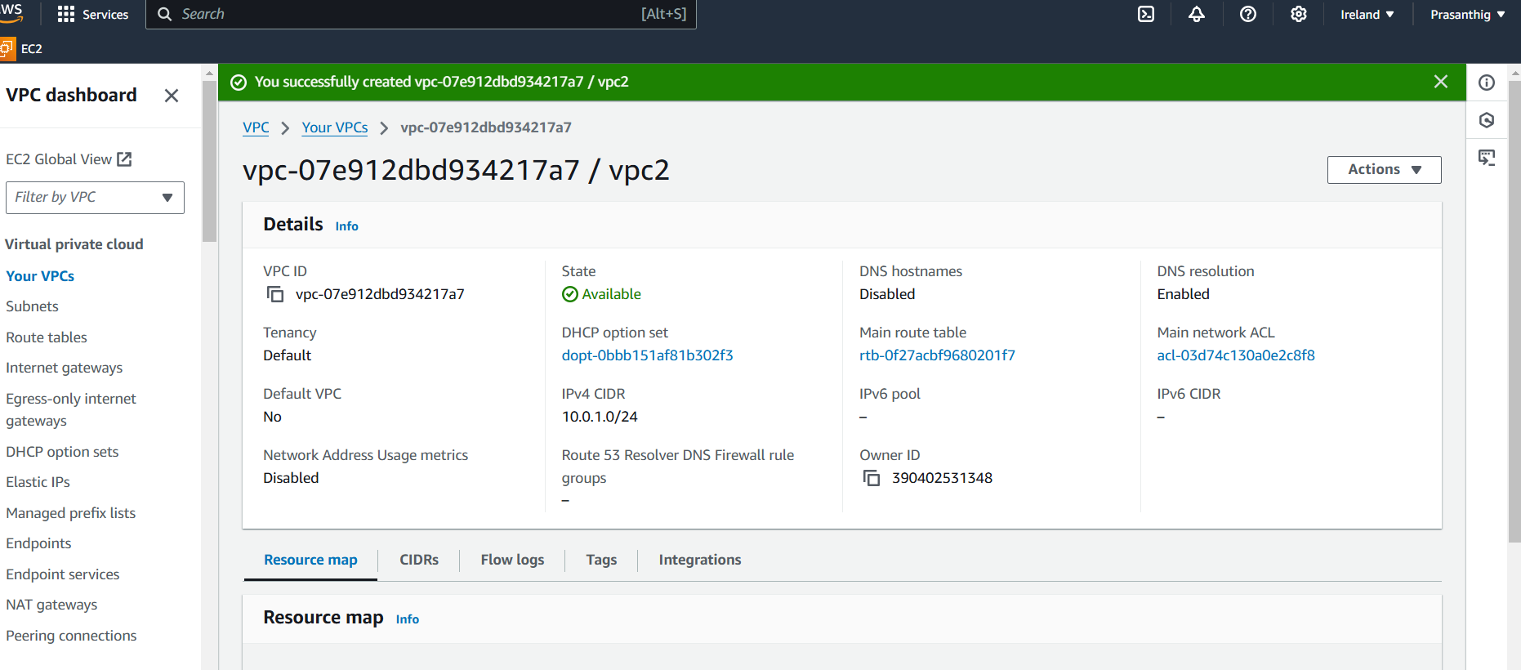

Created VPC in London region🡪VPC3

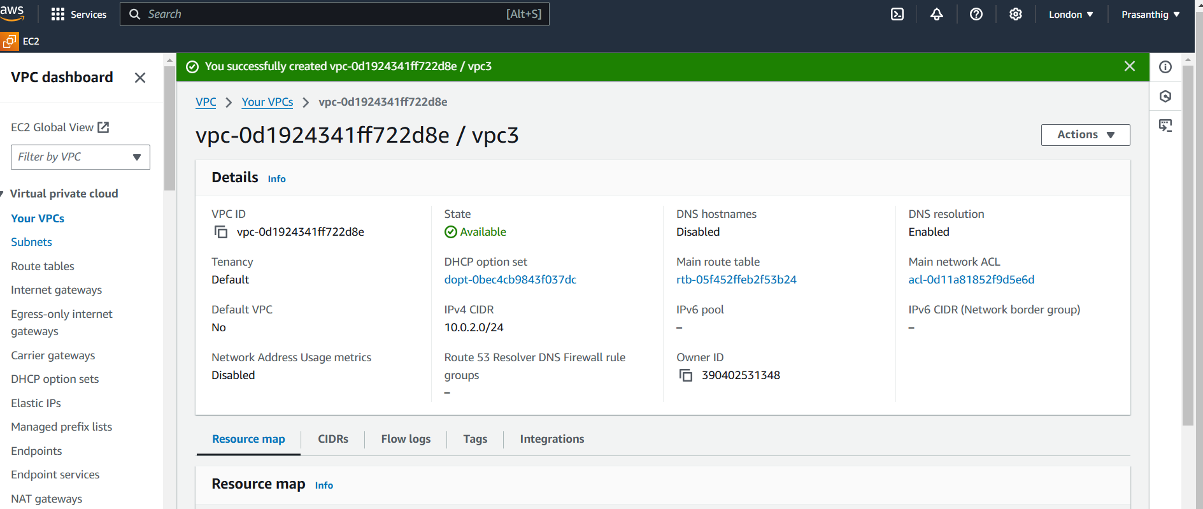

Created VPC in Paris Region🡪VPC4

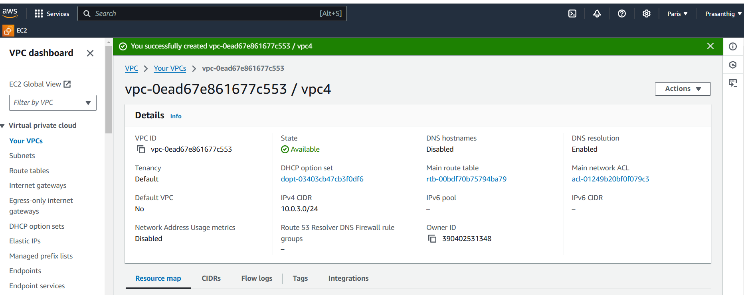

Creating a subnet for each VPC

Created a subnet for vpc1(Frankfurt)

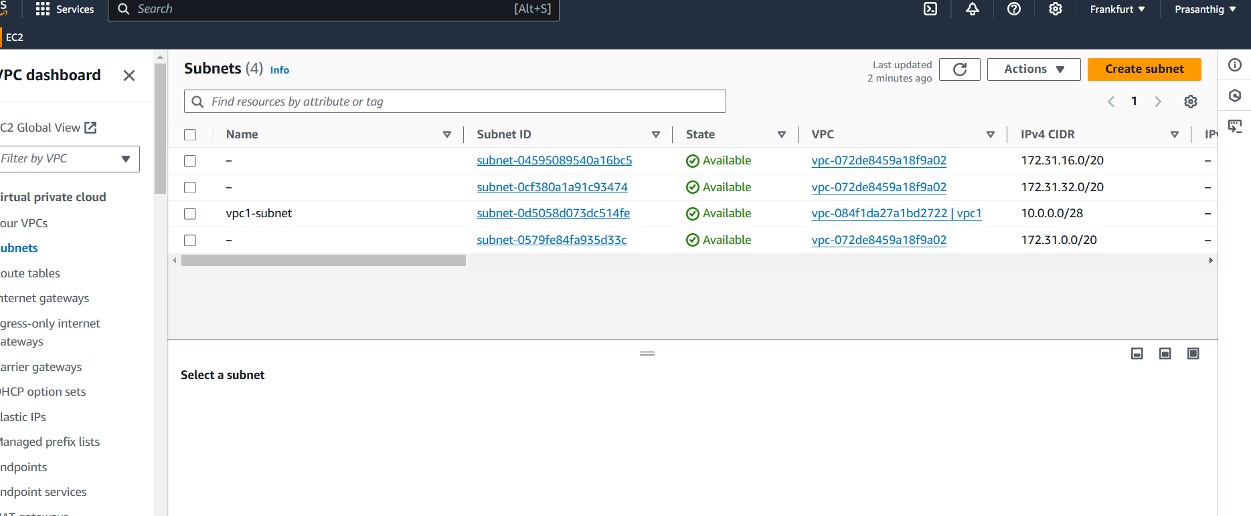

Created subnet for VPC2 (Ireland)

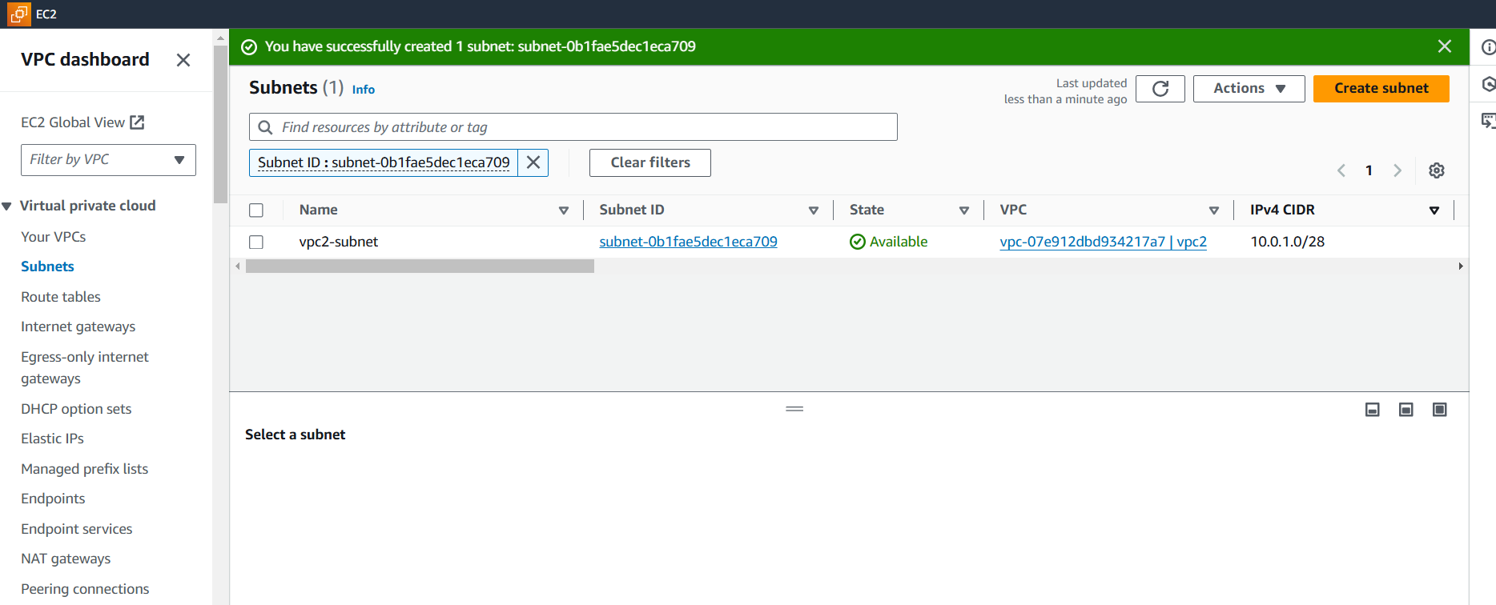

Created Subnet for VPC3(London)

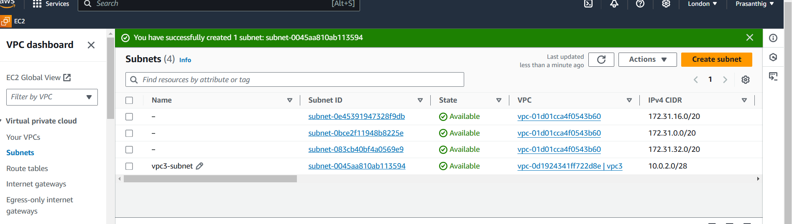

Created the subnet for VPC4(Paris)

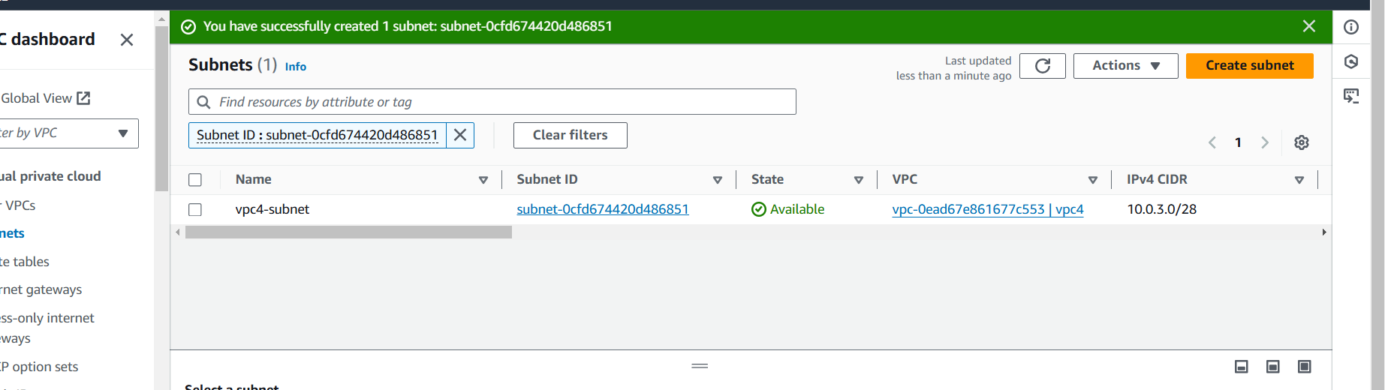

Created Transit Gateway in Frankfurt

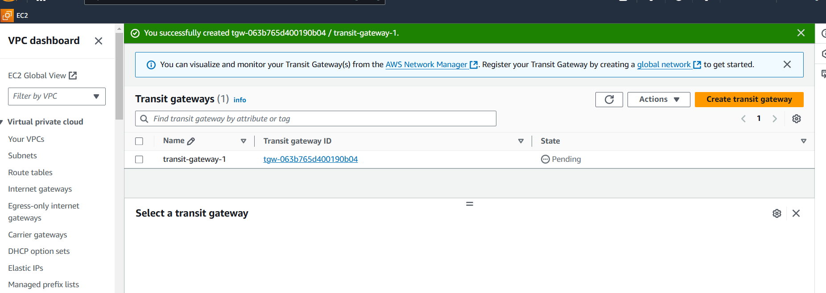

Created Transit Gateway in Ireland

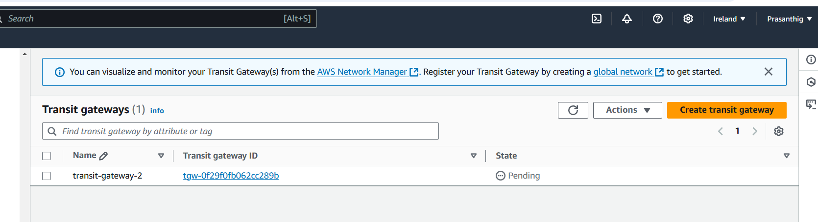

Created Transit Gateway in London

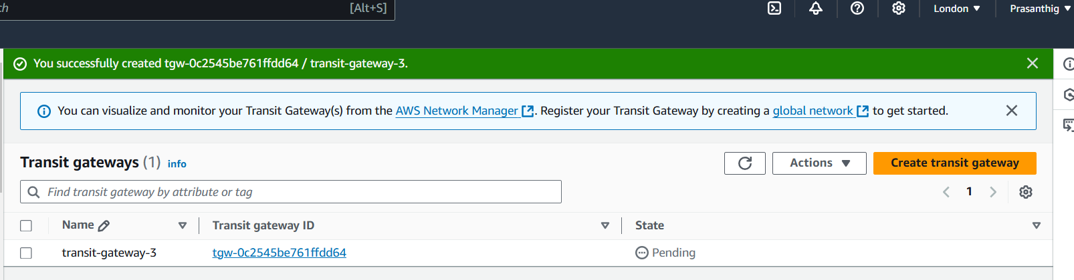

Created Transit Gateway in Paris

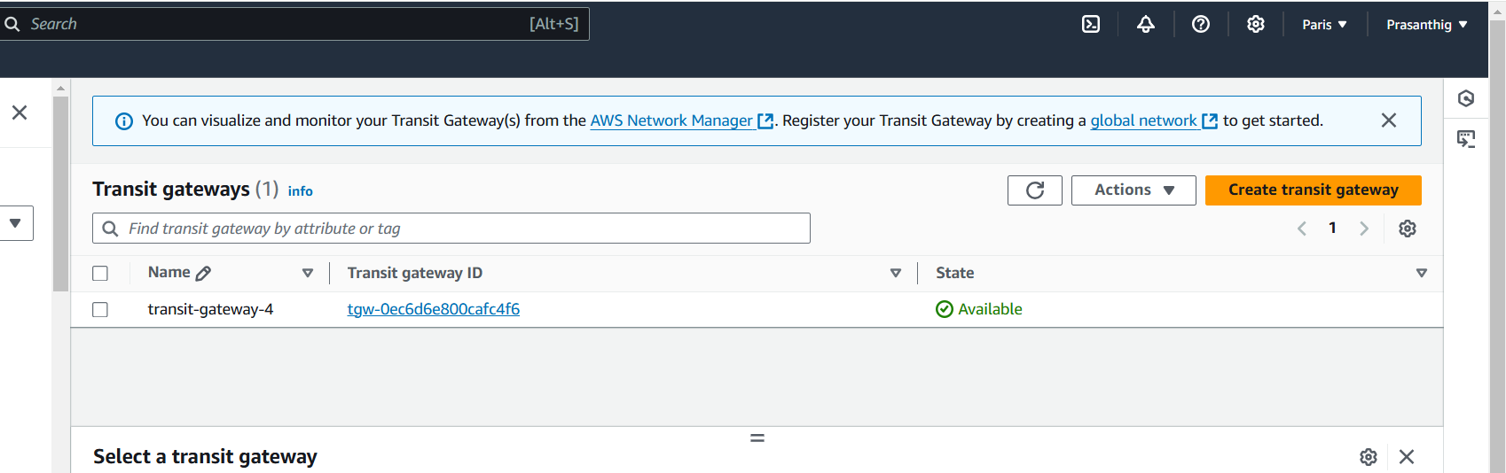

Creating Transit Gateway Attachment

Created TGA for VPC1(local),peering (Ireland,London,Paris)

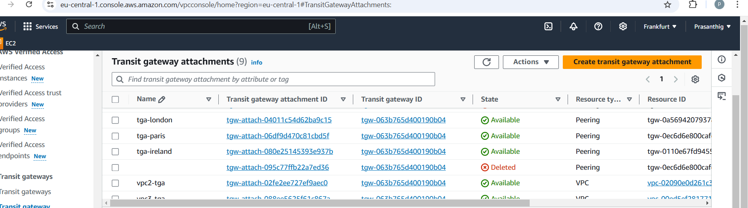

Created TGA for VPC2(local),peering (Frankfurt,London,Paris)

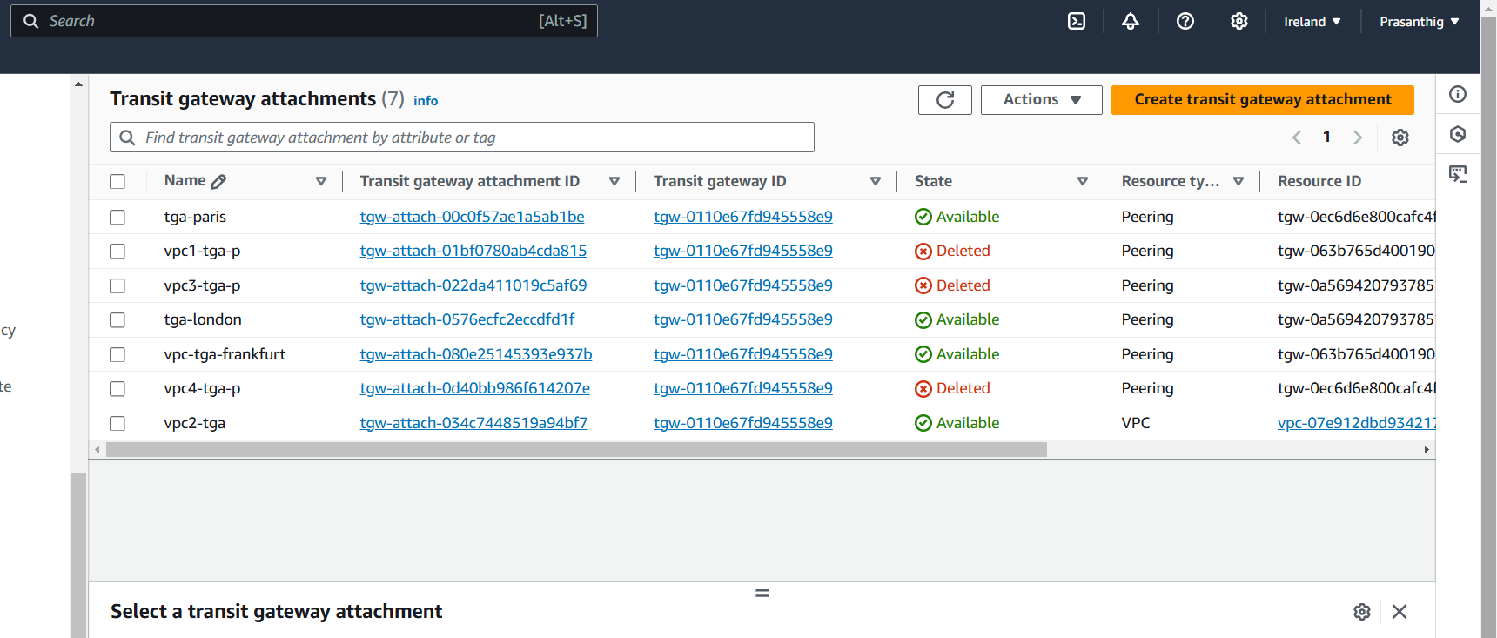

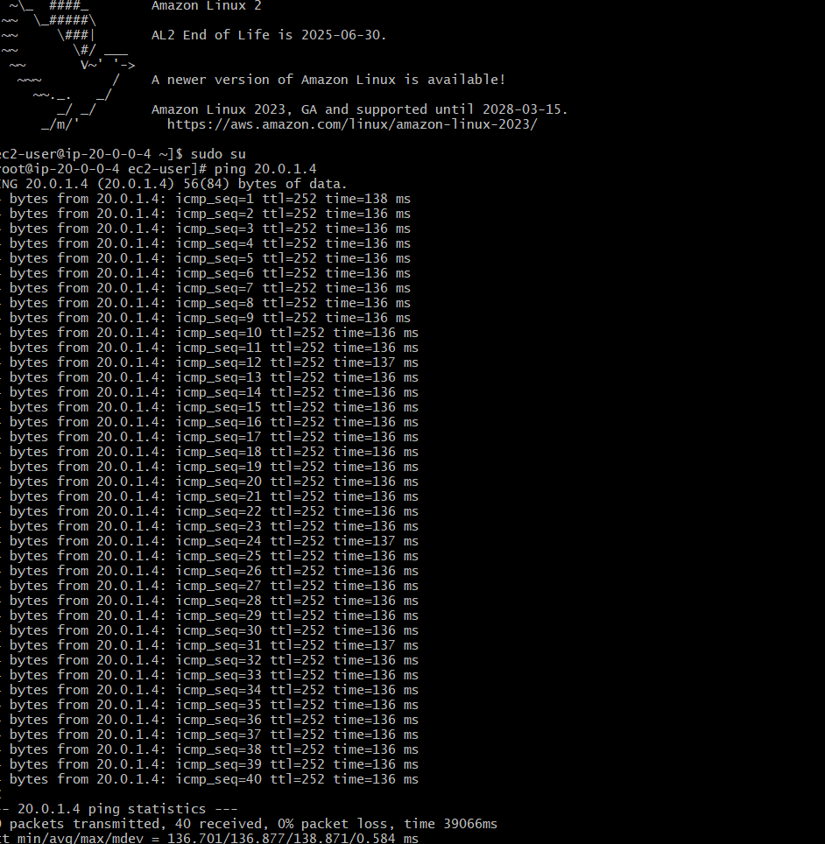

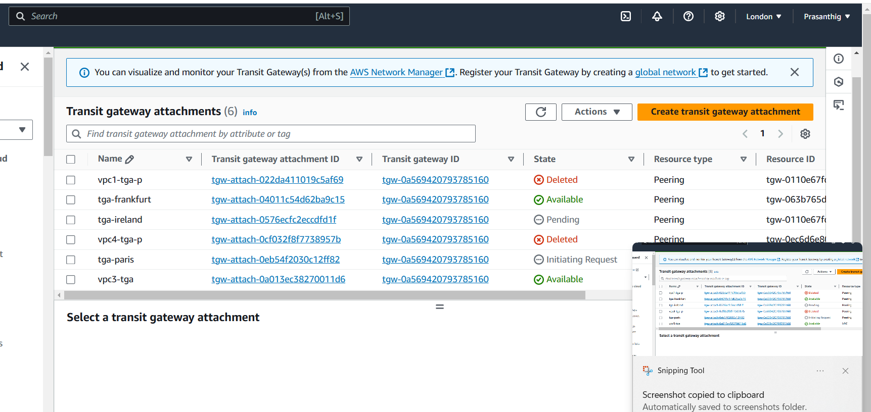

Created TGA for VPC4(local),peering (Frankfurt,Ireland,London)

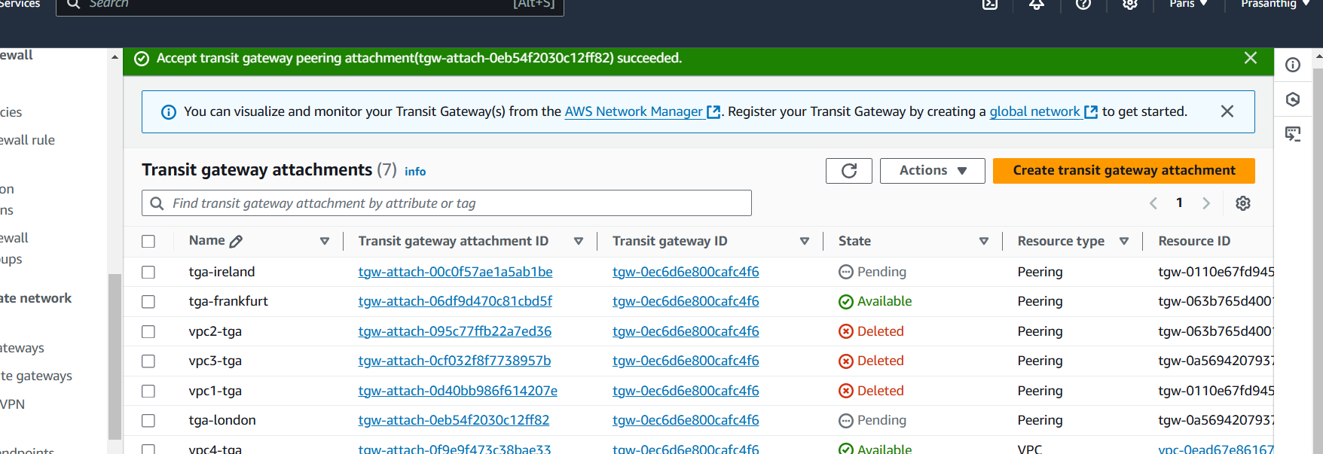

TG Route tables are created associated with all the regions and local

